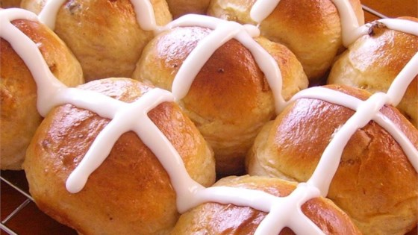

**HOT CROSS BUNS**

4$qqw\qqw\sdsd sdsd\qqw|

Hot cross buns, hot cross buns, 1 a pen-ny, 2 a pen-ny, hot cross buns.

**B A G B A G G G G G A A A A B A G**



**HOT CROSS BUNS**

4$qqw\qqw\sdsd sdsd\qqw|

Hot cross buns, hot cross buns, 1 a pen-ny, 2 a pen-ny, hot cross buns.

**B A G B A G G G G G A A A A B A G**